- Create one IAM user and assign ec2,s3 full access role.

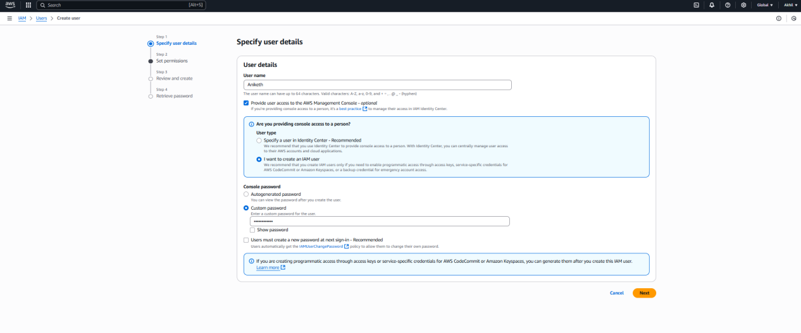
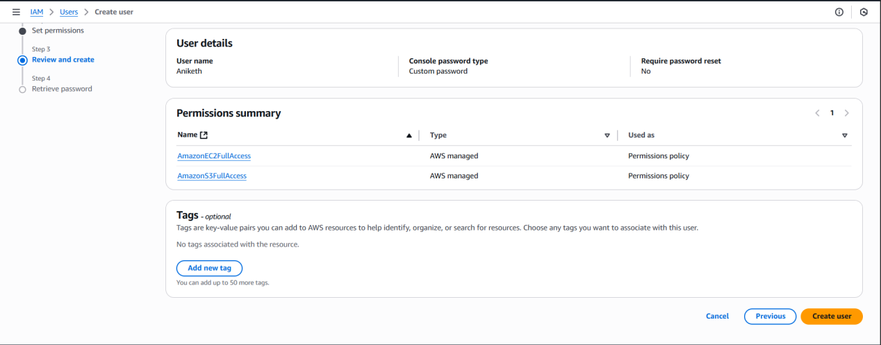

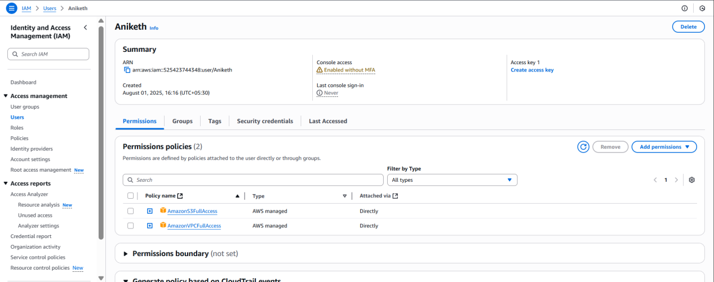

- Create one Group in IAM and Assign Read access for ec2.

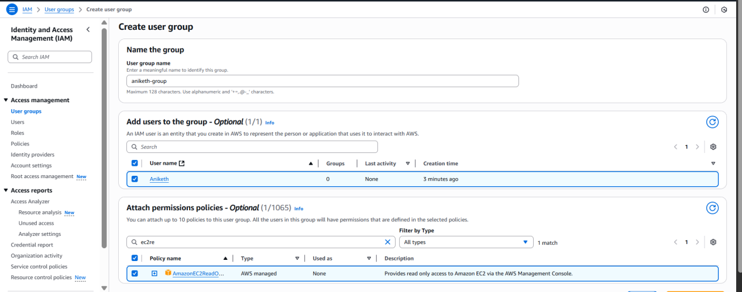

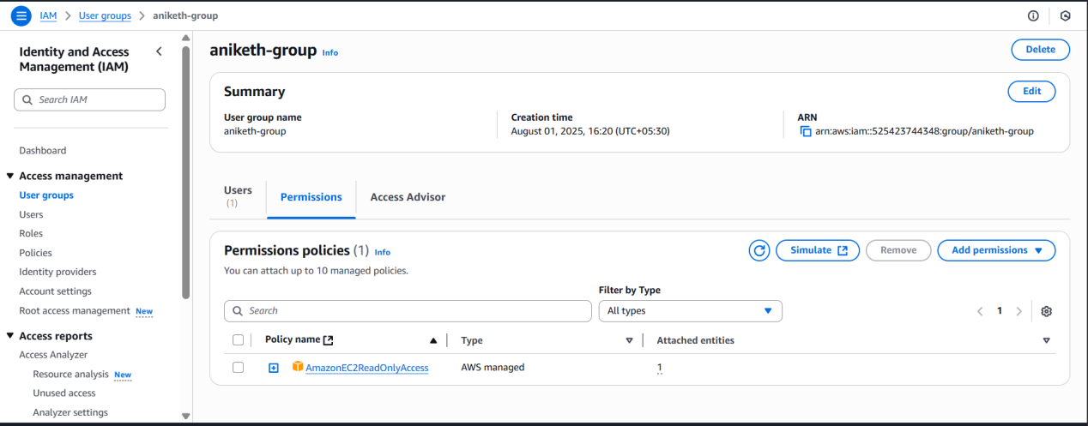

- Create a new user with name Devops and add to the group created in task2.

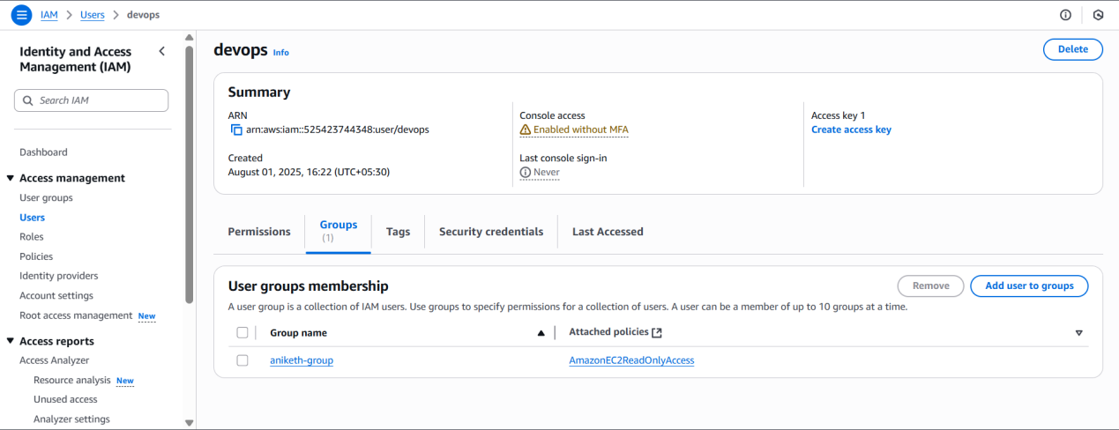

- Write a bash script to create a IAM user with VPC full access.

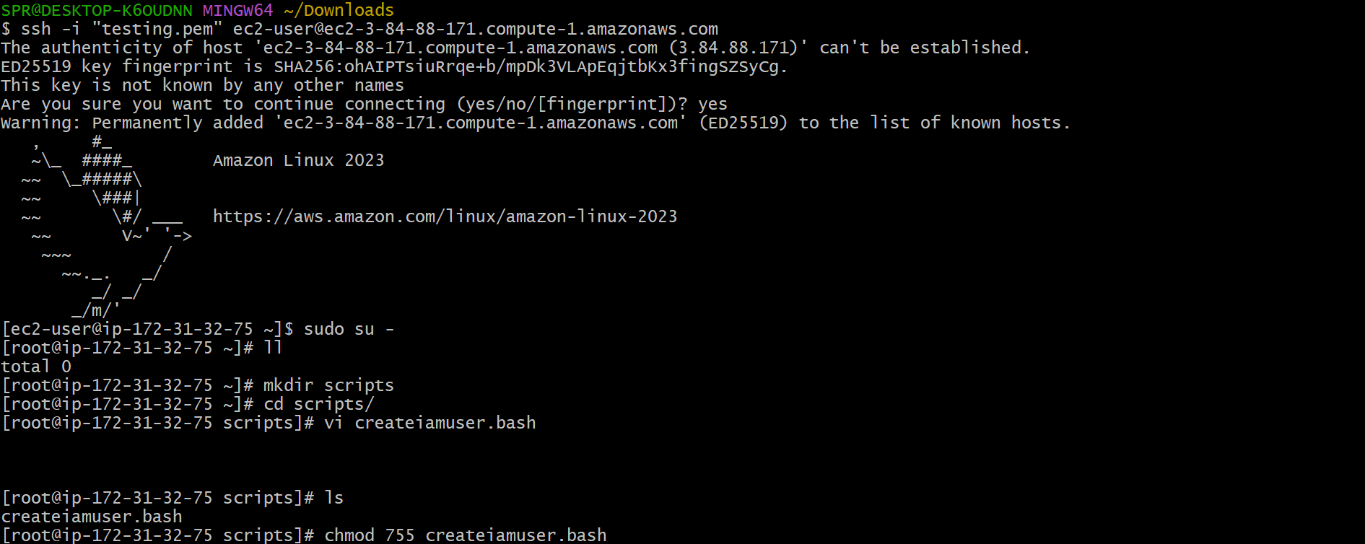

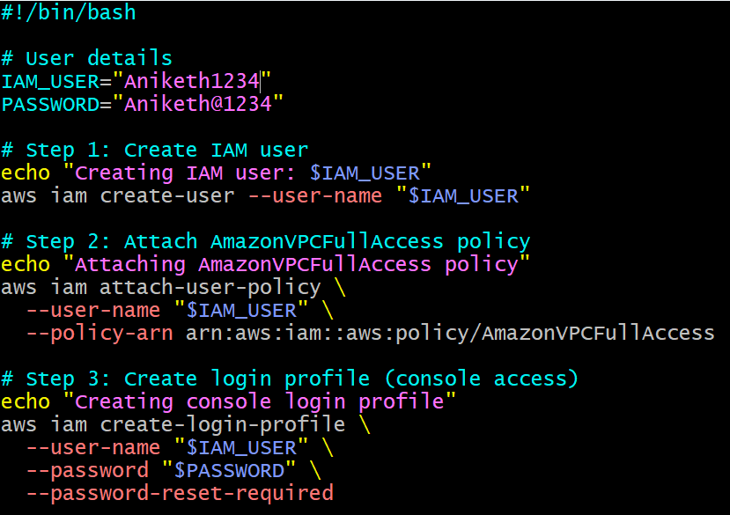
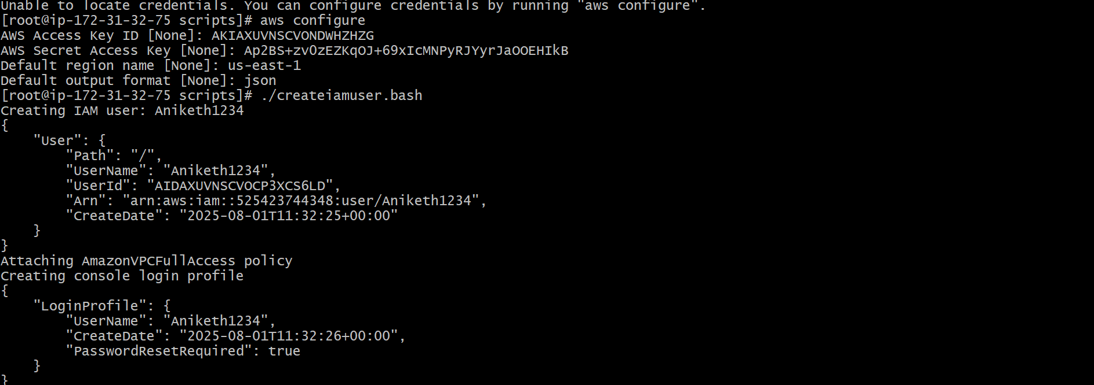

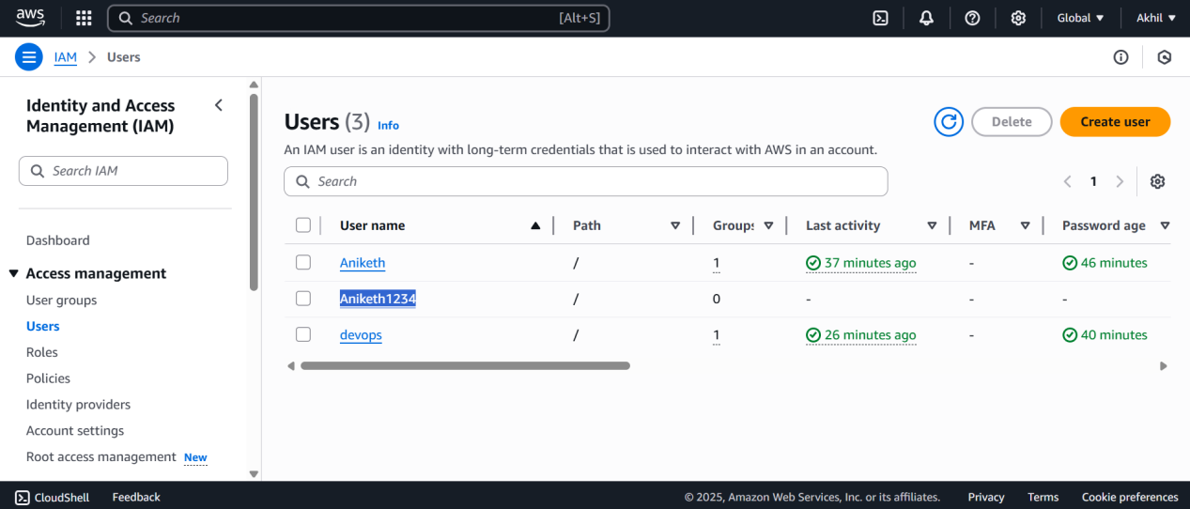

- Create an IAM policy to allow EC2 access for a specific user in specific regions only.
# 🧭 **Steps to Create the IAM Policy (AWS Console)**
### **1. Go to IAM Console**
* Open: [https://console.aws.amazon.com/iam](https://console.aws.amazon.com/iam)
* In the left menu, click **Policies**
* Click **Create policy**
# **2. Choose JSON Tab**
You will paste a custom policy.
# **3. Paste the Policy (Allow EC2 in specific regions)**
Replace:
* `"us-east-1"` and `"ap-south-1"` with your allowed regions.
* Add/remove regions as needed.
```json
{
"Version": "2012-10-17",
"Statement": [
{
"Sid": "AllowEC2InSpecificRegions",
"Effect": "Allow",
"Action": "ec2:*",
"Resource": "*",
"Condition": {
"StringEquals": {
"aws:RequestedRegion": [
"us-east-1",
"ap-south-1"
]
}
}
},
{
"Sid": "DenyEC2InOtherRegions",
"Effect": "Deny",
"Action": "ec2:*",
"Resource": "*",
"Condition": {
"StringNotEquals": {
"aws:RequestedRegion": [
"us-east-1",
"ap-south-1"
]
}
}
}
]
}
# 🔍 Explanation
### **Statement 1 — Allow only in specified regions**
Allows EC2 actions *only if* the requested region matches the allowed ones.
### **Statement 2 — Explicit deny**
AWS always evaluates DENY first.
This ensures the user **cannot use EC2 in ANY other region**, even if they gain extra permissions somewhere else.
# **4. Review and Create**
1. Click **Next**
2. Name the policy (example):
**Allow-EC2-Only-Specific-Regions**
3. Add optional description.
4. Click **Create policy**
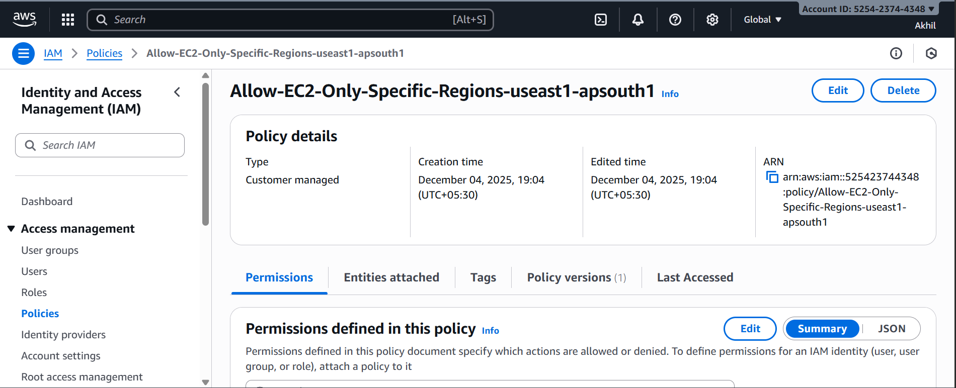
# **5. Attach the Policy to a Specific User**
1. Go to **Users** → Select your user
2. Open **Permissions**
3. Click **Add permissions**
4. Choose **Add permissions directly**
5. Select the policy you created
6. Click **Add permissions**
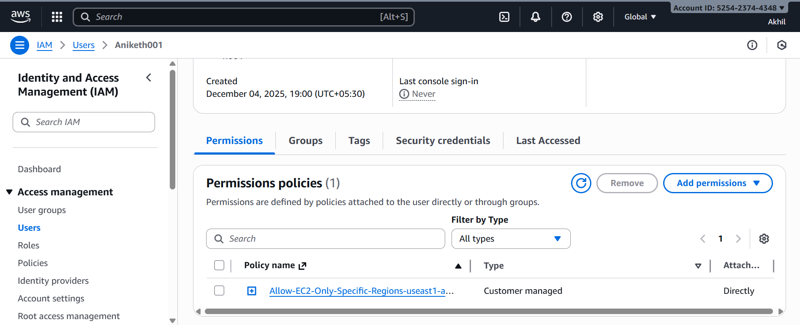
Now the user can manage EC2 **only** in the specific regions you selected. Not others
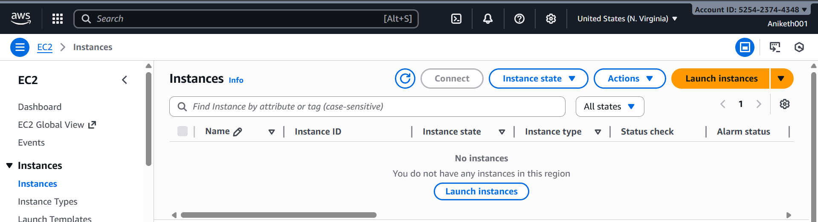
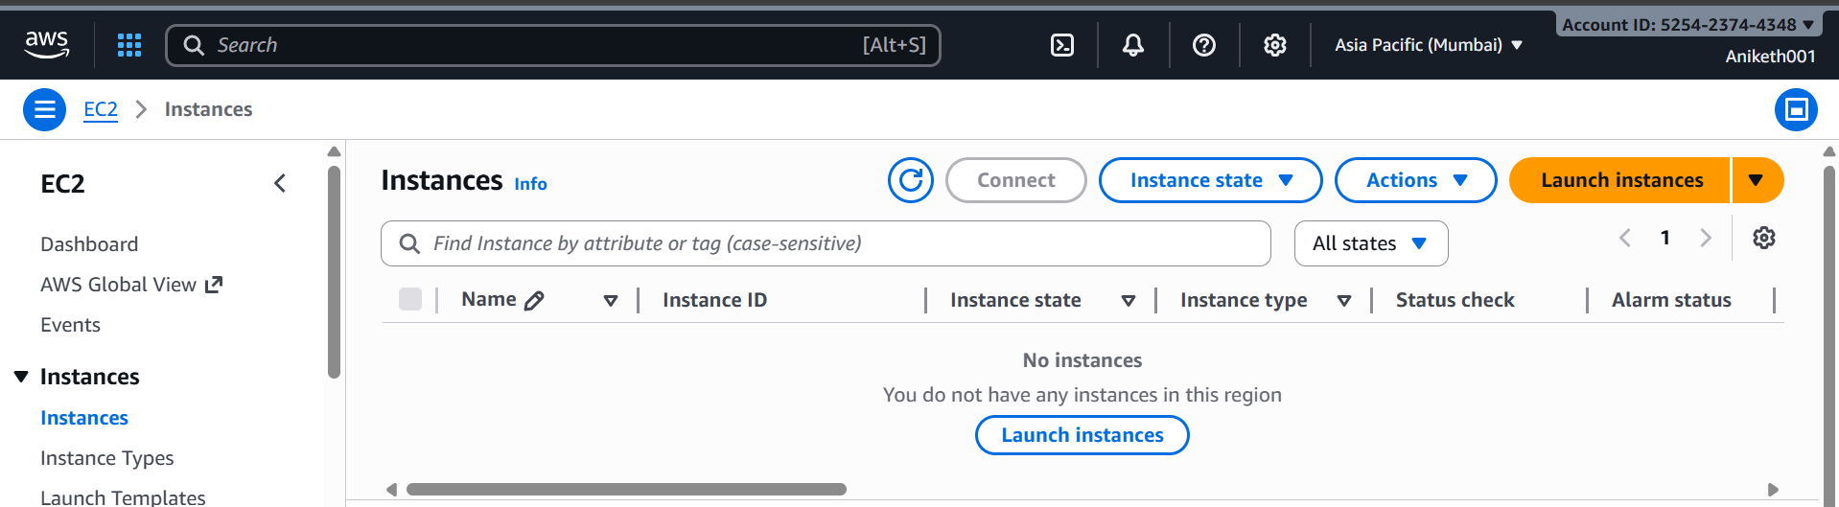

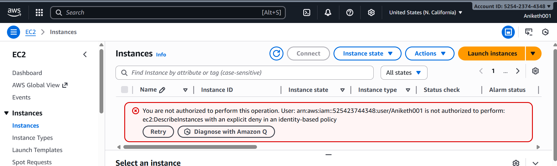
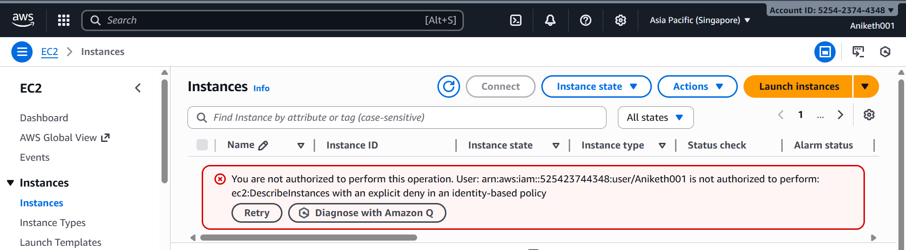

6) We have two accounts Account A and Account B, Account A user should access s3 bucket in Account B. (Collaborate with team member and execute this.Mostly asked in every interview)

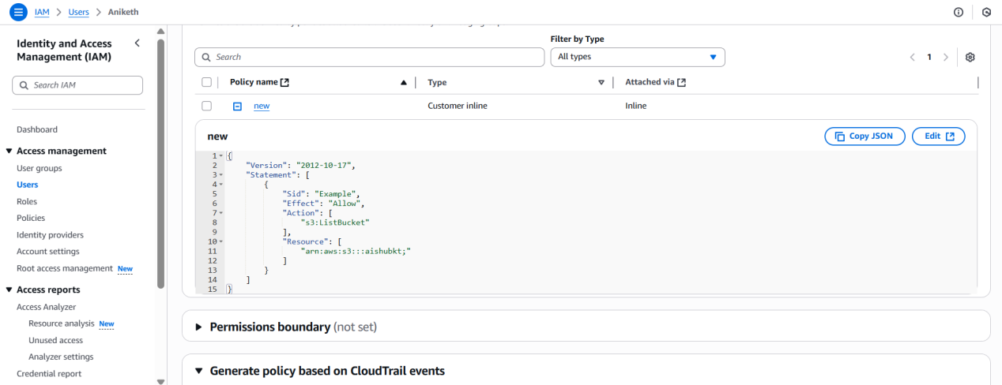

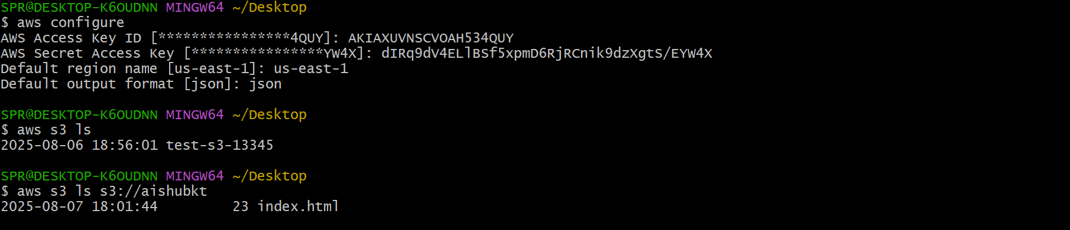

bucket policy ::===

{
"Version": "2012-10-17",
"Statement": [
{
"Sid": "Example permissions",
"Effect": "Allow",
"Principal": {
"AWS": "arn:aws:iam::(id of other account):root"
},
"Action": [
"s3:GetLifecycleConfiguration",
"s3:ListBucket"
],
"Resource": [
"arn:aws:s3:::(bucketname)"
]
}
]
}

iam user policy ::::===

{
"Version": "2012-10-17",
"Statement": [
{
"Sid": "Example",
"Effect": "Allow",
"Action": [
"s3:ListBucket"
],
"Resource": [
"arn:aws:s3:::(bucketname);"
]
}
]
}

